The rise of magnetism in Latin-American countries

L. S. Spin*a*, F. M. Magnon*b*, and S. P. Wave*c*

*a* Institut für Theoretische Physik, Universität Göttingen, Göttingen, Germany

*b* Ukrainian Physico-Technical Institute, Academy of Sciences of the Ukrainian SSR, Kharkov, Ukraine

*c* University of Grenoble, Grenoble, France. law3m2023@usm.cl

The study of magnetism and magnetic materials has become an important field of research in Latin America. The Latin American Workshop on Magnetism, Magnetic Materials, & their Applications (LAW3M) is an essential scenario to show the recent developments in the field. The LAW3M started in 1991, with its first version in Havana (Cuba). Since then, it has been realized every 2-3 years in Central and South American countries. The LAW3M is an important conference in Latin America, which join students, researchers, and academics devoted to magnetism from around the world, including the participation of renowned scientists in the form of plenary and invited talks. It is a unique opportunity to present cutting-edge research developed by Latin American researchers to the scientific community.

The 12th version of the LAW3M will be held from October 16th to 20th (2023) in the southern city of Puerto Varas (Chile), located on the shore of the Llanquihue Lake and is easily reachable from Puerto Montt's airport. This area is the gate to Patagonia and is recognized for its natural beauty.

Please use the font "Times New Roman". For the title, use font size 14 and bold letters. For the author's list, use a font size of 12, highlighting the presenter and including an e-mail. For the affiliations and main text, use font size 11. For the caption and references, use font size 10. The abstract (including title, authors, affiliations, text, figures, tables, bibliography, ...) must be accommodated in just one page".

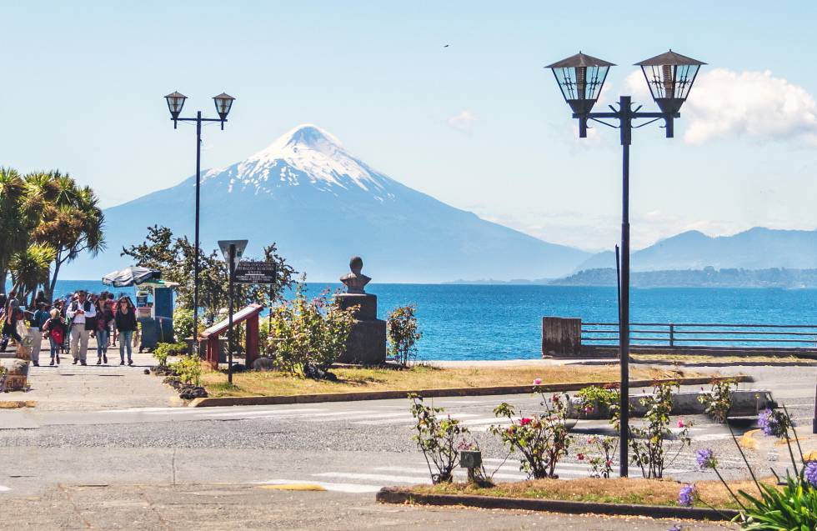

Fig. 1: View of the Llanquihue lake and the Osorno volcano in Puerto Varas, Chile.

[1] W. F, Brown, J. Appl. Phys. **30**, S62 (1959).