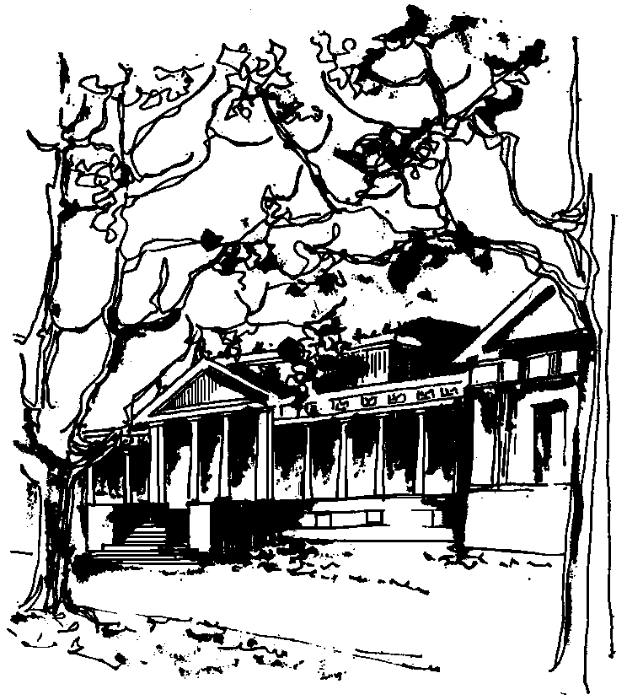


Departamento de Física Calle 49 y 115
Facultad de Ciencias Exactas La Plata
Universidad Nacional de La Plata

SEMINARIOS DEL IFLP y DEL DEPARTAMENTO
Día y horario especiales: MIÉRCOLES 13 de DICIEMBRE – 11hs
AULA CHICA

TÍTULO: "Non-degenerate optical parametric oscillator beyond rotating wave approximation"

EXPOSITOR: Swapan Mandal
Department of Physics, Visva-Bharati, Santiniketan, India

Resumen: Under strong pump condition, the Hamiltonian and hence the equation of motion of the field operators of a non-degenerate parametric oscillator is formulated. The coupled operator differential equations involving the signal and idler fields are solved analytically up to the second order in dimensionless interaction time. We do not use the rotating wave approximation (RWA) for getting these analytical solutions. These solutions are used to investigate the squeezing, mixed mode squeezing, amplitude squared squeezing and principal squeezing of the input light prepared in composite coherent and in Fock states. Interestingly, the squeezing, mixed mode squeezing etc are unavailable if the rotating wave approximated solutions are used. In spite of the inexactness of the solutions, we are successful in getting various nonclassical properties of the radiation field. We believe the approach and hence the solution is fresh and will be of use for further investigation on non-degenerate parametric oscillator.

