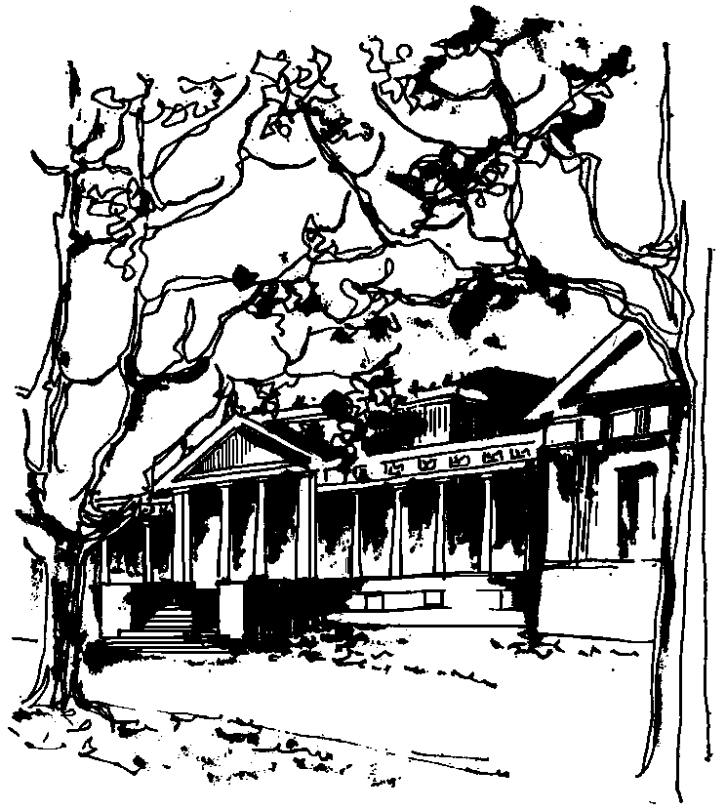
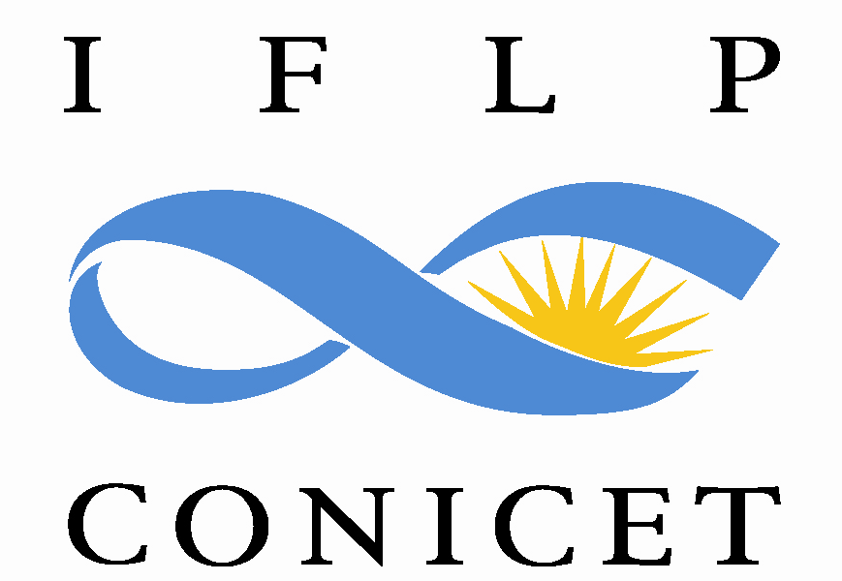

Departamento de Física Calle 49 y 115
Facultad de Ciencias Exactas La Plata
Universidad Nacional de La Plata

SEMINARIOS DEL IFLP y DEL DEPARTAMENTO
MARTES 4 de JULIO – 10:30 hs
AULA CHICA

TÍTULO: "X-ray absorption spectroscopies to study bulk, surfaces and nanoparticles"

EXPOSITOR: Yves Joly

Institut Néel, CNRS/Université Grenoble Alpes, Grenoble, France

Resumen: After an introduction on X-ray absorption spectroscopy and some of its properties, the purpose is to briefly present the ab initio code, FDMNES, simulating the experimental spectra obtained using this technique. More specifically adapted to the near edge region (XANES), it allows as well, the simulation of related spectroscopies such as X-ray Raman Spectroscopy, Resonant X-ray Diffraction and the Surface Resonant X-ray Diffraction (SRXD). For XANES, an example of use will be proposed for the study of platinum sub-nanometric particles adsorbed on alumina and, under Hydrogen pressure. In that case, the job was made far easier by the use of the high resolution fluorescence mode to record the experimental spectra. The most recent development on SRXD will give the opportunity to show its potentiality to study thin film and liquid-surface interfaces in electrochemical conditions.

