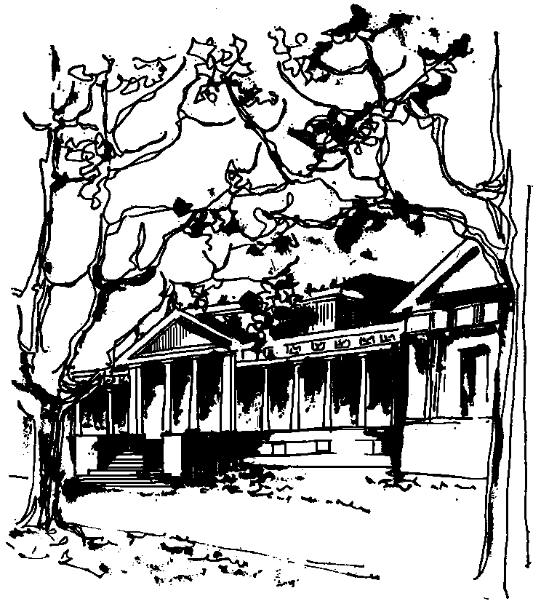
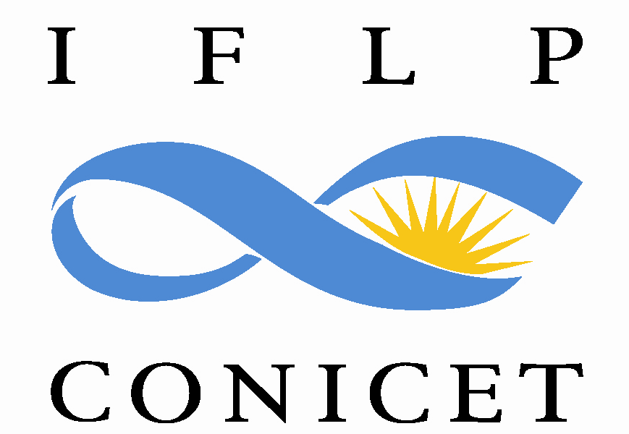

Departamento de Física Calle 49 y 115
Facultad de Ciencias Exactas La Plata
Universidad Nacional de La Plata

SEMINARIOS DEL IFLP y DEL DEPARTAMENTO
MARTES 4 de JULIO – 10:30 hs
AULA CHICA

TÍTULO: "X-ray absorption spectroscopies to study bulk, surfaces and nanoparticles"

EXPOSITOR: Yves Joly

Neel Institute, Grenoble, France

Resumen:

It is known for more than 30 years that quantum Dirac fermions in odd dimensional spaces possess the so called parity anomaly related to the spectral asymmetry of the Dirac operator. As a result, the Chern-Simons action with the level k=1/2 is induced in 3D. We have studied Dirac fermions on four-dimensional manifolds with boundaries and demonstrated that a similar phenomenon takes place: spectral asymetry of the Dirac operator leads to a boundary Chern-Simons term. We found a somewhat unusual Chern-Simons level k=1/4, which is however consistent with the counting of boundary degrees of freedom.

