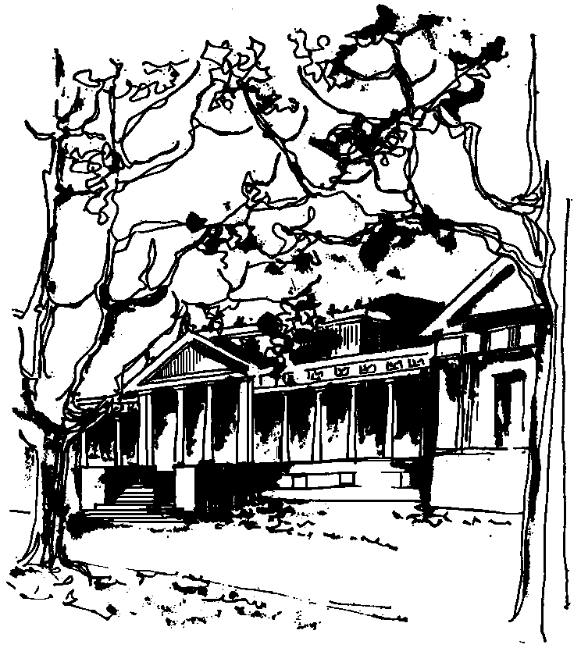


Departamento de Física Calle 49 y 115
Facultad de Ciencias Exactas La Plata
Universidad Nacional de La Plata

SEMINARIOS DEL IFLP y DEL DEPARTAMENTO
Día y horario especiales
MARTES 22 de MAYO – 12:30 hs
AULA CHICA

TÍTULO: "Parity anomaly in four dimensions"

EXPOSITOR: Dmitry Vassilevich

Tomsk State University & Universidade Federal do ABC

Resumen: It is known for more than 30 years that quantum Dirac fermions in odd dimensional spaces possess the so called parity anomaly related to the spectral asymmetry of the Dirac operator. As a result, the Chern-Simons action with the level k=1/2 is induced in 3D. We have studied Dirac fermions on four-dimensional manifolds with boundaries and demonstrated that a similar phenomenon takes place: spectral asymetry of the Dirac operator leads to a boundary Chern-Simons term. We found a somewhat unusual Chern-Simons level k=1/4, which is however consistent with the counting of boundary degrees of freedom.

