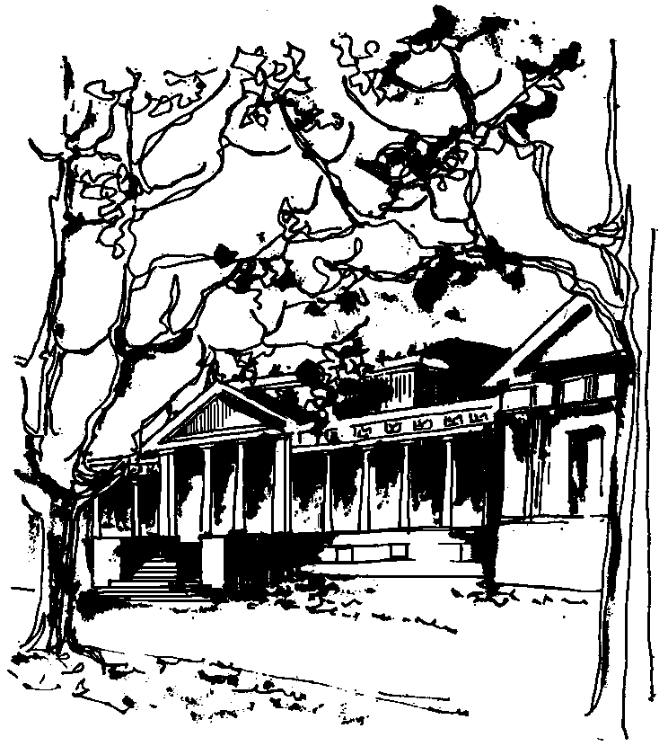


Departamento de Física Calle 49 y 115
Facultad de Ciencias Exactas La Plata
Universidad Nacional de La Plata

SEMINARIOS DEL IFLP y DEL DEPARTAMENTO
MARTES 2 de MAYO – 10:30 hs
AULA CHICA

TÍTULO: "Modelling Higher-order correlations in multi-neuron inputs and outputs in a population of neurons"

EXPOSITOR: Dr Fernando Montani

IFLYSIB – CONICET/UNLP

Resumen: To understand how sensory information is processed in the brain, we need to investigate how information is represented collectively by the activity of a population of neurons. Information can be carried in spike rate, spike timing, and spike correlations across neurons. Spike correlations across neurons are widely found in the brain, and the evidences show that pairwise correlations do not by themselves account for multineuronal firing patterns. Indeed, the relationship between noise and signal correlations, when considering higher order correlations can lead either to redundancy or synergy at population level. Evidence shows that higher order correlations in the neuronal inputs and the spiking outputs follow a non-Gaussian statistics suggesting the need of developing a new theoretical framework taking into account the complexity of synchronous activity patterns. We analyze how input statistics are transformed through a threshold process into output statistics, and investigate the conditions that may lead to higher-order correlations in a neuronal ensemble. This allows us to define a new scenario for the interplay between pairwise and higher-than-pairwise interactions.

