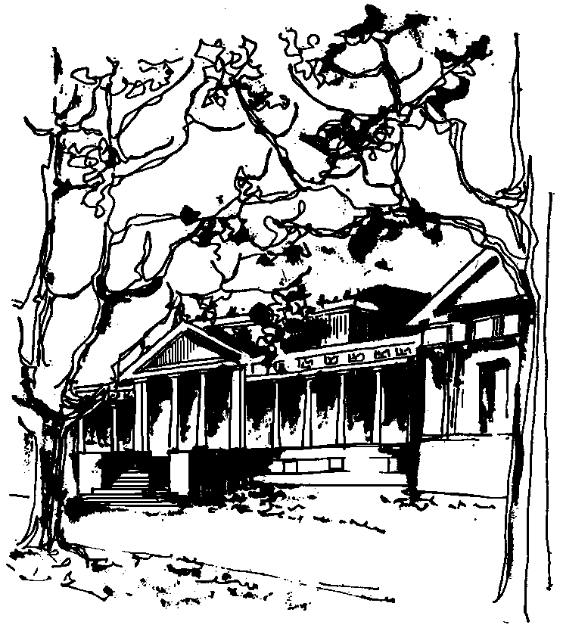


Departamento de Física Calle 49 y 115
Facultad de Ciencias Exactas La Plata
Universidad Nacional de La Plata

SEMINARIOS DEL IFLP y DEL DEPARTAMENTO
Día y Horario especiales: JUEVES 27 de ABRIL – 10:10 hs
AULA CHICA

TÍTULO: "2D Critical Casimir forces between inhomogeneous boundaries"

EXPOSITOR: Raoul Santachiara

Laboratoire de Physique Theorique et Modeles Statistiques de la Universite de Paris-Sud

Resumen: Systems as diverse as binary mixtures and inclusions in biological membranes, and many more can be described effectively by interacting spins. When the critical fluctuations in these systems are constrained by boundary conditions, critical Casimir forces (CCF) emerge. Here we analyze CCF between boundaries with alternating boundary conditions in two dimensions, employing conformal field theory (CFT). Interestingly we will discuss about a new form of the Szego-Widow theorem for block Toepliz matrices

