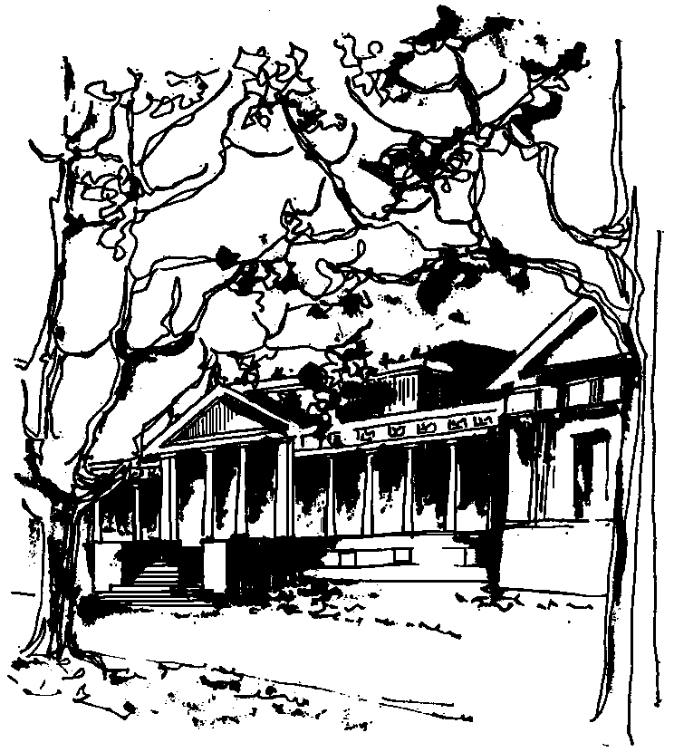


Departamento de Física Calle 49 y 115
Facultad de Ciencias Exactas La Plata
Universidad Nacional de La Plata

SEMINARIOS DEL IFLP y DEL DEPARTAMENTO
MARTES 4 de ABRIL – 11 hs
AULA CHICA

TÍTULO: " Non selfadjoint Hamiltonians: quantum mechanics and far beyond"

EXPOSITOR: Ignat Fialkovskiy
Universidade Federal do ABC, Santo André

Resumen: We will discuss the use of non-hermitian Hamiltonians in a variety of physical problems from quantum mechanics to waves propagation. An asymptotic approach will be developed for construction of adiabatic solutions, and also for treating eigenvalues degeneracy. In the latter case two regimes of mode transformation are identified: avoided crossing of eigenvalues, corresponding to complex degeneracy points, and the explicit unavoidable crossing (with real degeneracy points). Both cases are treated by method of matched asymptotic expansions in the context of a unifying approach, applicable to a wide range of physical problems.

