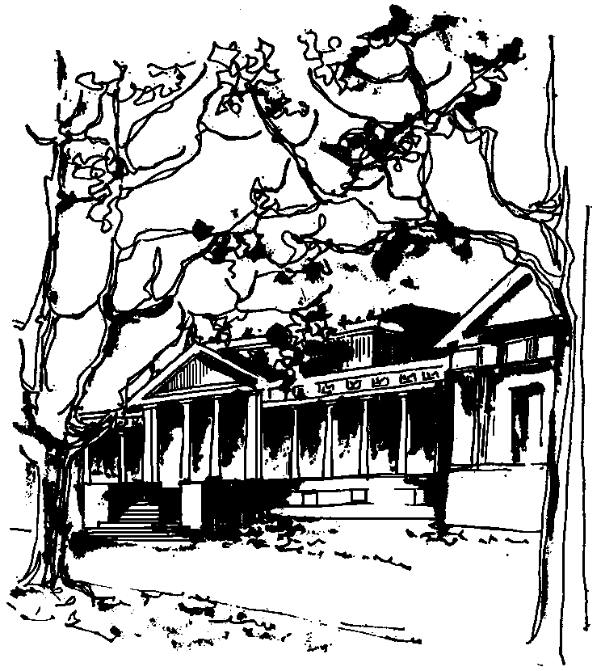


Departamento de Física Calle 49 y 115
Facultad de Ciencias Exactas La Plata
Universidad Nacional de La Plata

COLOQUIO DEL IFLP y DEL DEPARTAMENTO

DÍA Y HORARIO ESPECIALES: JUEVES 2 de MARZO – 10:30 hs
AULA CHICA

TÍTULO: "Cosmic strings - a window to the very early universe?"

EXPOSITOR: Prof. Betti Hartman
Universidade de Sao Paulo (Sao Carlos), Brasil

Resumen: Topological defects (aka topological solitons) appear in field theory models with spontaneous symmetry breaking and a non-trivial vacuum manifold. Cosmic strings are created whenever a U(1) symmetry gets spontaneously broken and are the topological defect that seems most important from the point of view of cosmological applications. There are several reasons for this: on the one hand, it is believed that cosmic strings might be linked to the fundamental strings of String theory and on the other, essentially all models that try to embed the Theory of Inflation into the scheme of Grand Unification predict the production of cosmic strings. Furthermore, the analysis of recent Cosmic Microwave Background (CMB) data suggests that cosmological models containing cosmic strings provide a viable fit to both the temperature as well as polarization anisotropy spectra. I will discuss the properties of cosmic strings and explain why - with high precision cosmological data - they provide an interesting testing ground for physics at very high energies and hence the primordial universe.

