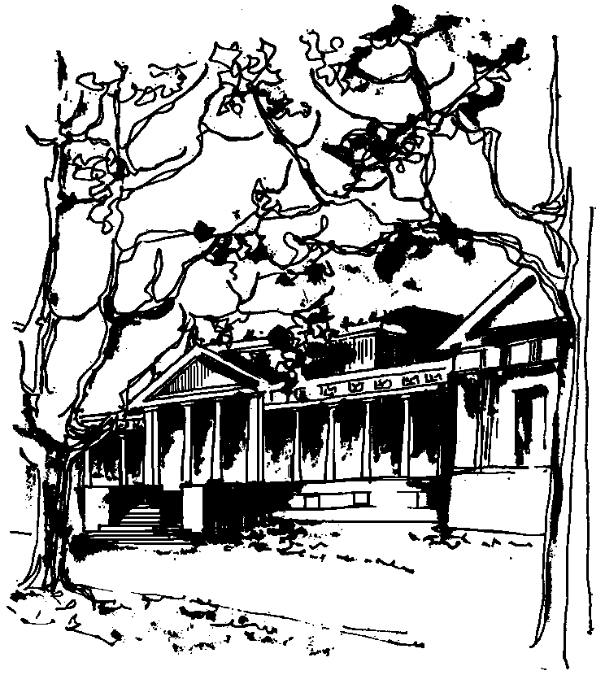


Departamento de Física Calle 49 y 115
Facultad de Ciencias Exactas La Plata
Universidad Nacional de La Plata

CURSO BREVE del IFLP y DEPARTAMENTO DE FÍSICA

DESTINADO A ESTUDIANTES GRADUADOS E INVESTIGADORES

Martes 9 de agosto a las 11hs. Aula Chica
Jueves 11 de agosto a las 15hs. Aula Chica

TÍTULO: An introduction to affine differential geometry

EXPONE: Peter B. Gilkey. Mathematics Department, University of Oregon, USA

RESUMEN: Let M be a smooth m-dimensional manifold and let ∇ be a connection on the tangent bundle of M. We say that the pair (M, ∇) is an affine manifoldif ∇ is torsion free, i.e., if ∇_XY-∇_YX=[X,Y] for any pair of vector fields X and Y. If (M,g) is a Riemannian manifold, let ∇^{g} be the Levi-Civita connection. Then, (M, ∇^{g}) is an affine manifold. Thus, the notion of an affine structure is a generalization of the notion of a Riemannian structure. In these lectures the notions of an affine Killing vector field and an affine gradient Ricci soliton will be defined. These will be examined in the context of homogeneous affine surfaces and the moduli space of homogeneous affine surfaces will be discussed.

