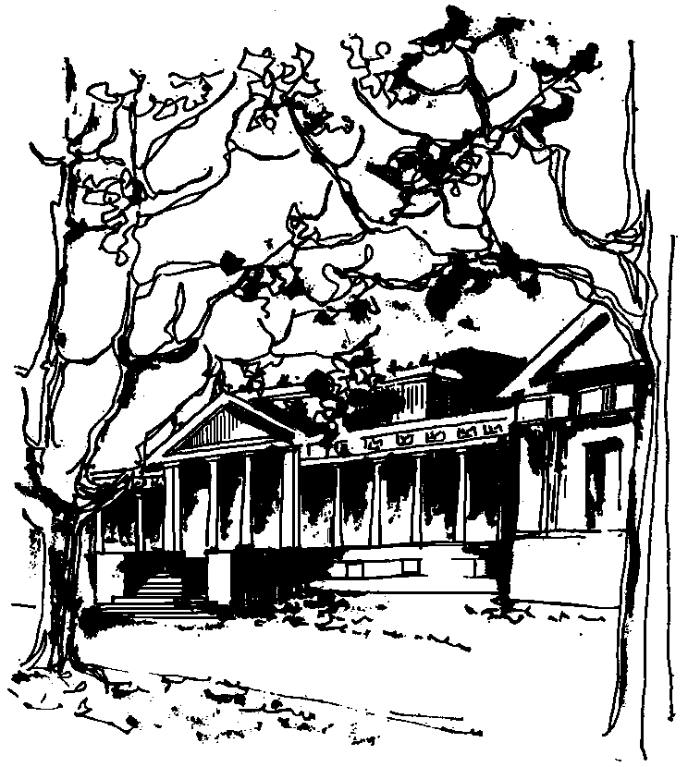


Departamento de Física Calle 49 y 115
Facultad de Ciencias Exactas La Plata
Universidad Nacional de La Plata

SEMINARIOS DEL IFLP y DEL DEPARTAMENTO

MARTES 21 de JUNIO a las 11hs
AULA CHICA

TÍTULO: Quantum Pattern Recognition

EXPONEN: Giuseppe Sergioli, Hector Freytes, Federico Holik, Martin Bosyk /University of Cagliari - University of La Plata

Resumen: We introduce a new framework for describing pattern recognition tasks by means of the mathematical language of density matrices.
In recent years, many efforts to apply the quantum formalism to non-microscopic contexts have been made and, in this direction, important contributions in the areas of pattern recognition and image understanding have been provided. Even if these results seem to suggest some possible computational advantages of an approach of this sort, an extensive and universally recognized treatment of the topic is still missing.
The natural motivations which have led to use quantum states for the purpose of representing patterns are
i) the possibility to exploit quantum algorithms to boost the computational intensive parts of the classification process,
ii) the possibility of using quantum-inspired algorithms for solving classical problems more effectively.
In our work, firstly we provide a one-to-one correspondence between patterns, expressed as n-dimensional feature vectors (according to the standard pattern recognition approach), and pure density operators (i.e. points in the n-dimensional Bloch hypersphere) called "density patterns". By using this correspondence, we give a representation of the well-known Nearest Mean classifier (NMC) in terms of quantum objects by defining an "ad hoc" Normalized Trace Distance (which coincides with the Euclidean distance between patterns in the real space).
Consequently, we have found a quantum version of the discriminant function by means of Pauli components, represented as a plane which intersects the Bloch sphere.
This first result suggests future potential developments, which consist in finding a quantum algorithm able to implement the normalized trace distance between density patterns with a consequent significative reduction of the computational complexity of the process.
But the main result we show consists in introducing a purely quantum classifier (QC), which has not any kind of classical counterpart, through a new definition of "quantum centroid". The convenience of using this quantum centroid lies in the fact that it seems to be more informative than the classical one because it takes into account also information about the distribution of the patterns.
As a consequence, the main implementative result consists in showing how this quantum classifier performs a significative reduction of the error and an improvement of the accuracy and precision of the algorithm with respect to the NMC (and also to other commonly used classifiers) on a classical computer.
The behaviors of QC and NMC on different datasets will be shown and compared.

