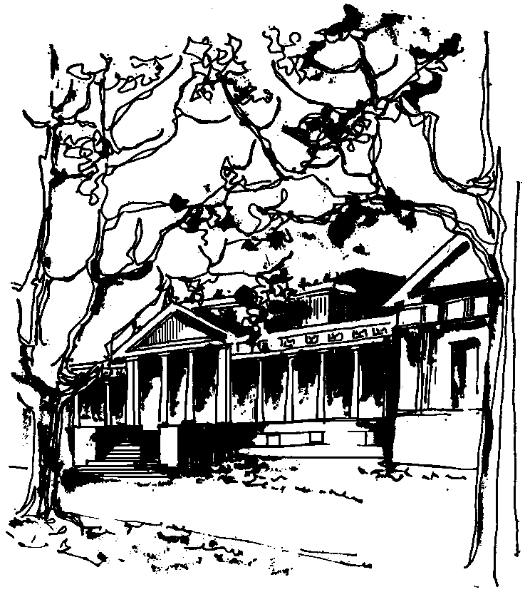


Departamento de Física Calle 49 y 115
Facultad de Ciencias Exactas La Plata
Universidad Nacional de La Plata

SEMINARIOS DEL IFLP y DEL DEPARTAMENTO
JUEVES 12 de MAYO a las 15hs
AULA CHICA

TÍTULO: Radion/Higgs phenomenology and the diphoton excess at the LHC

EXPONE: Anibal Medina
Institut de Physique Théorique (IPhT), Saclay

Resumen: Using an extra dimensional model as tool, we construct an effective four dimensional action that, via the AdS/CFT correspondence, describes the most general mixing between the only light states in the theory, the radion and the Higgs. Due to conformal invariance, once the Higgs scalar is localized in the bulk of the extra-dimension the coupling between the radion and the Higgs kinetic term vanishes, implying a suppressed coupling between the radion and massive gauge bosons. This leads us to consider that the diphoton excess recently presented by the ATLAS and CMS collaborations might originate from a radion in the bulk Higgs scenario within a warped extra dimensions.

