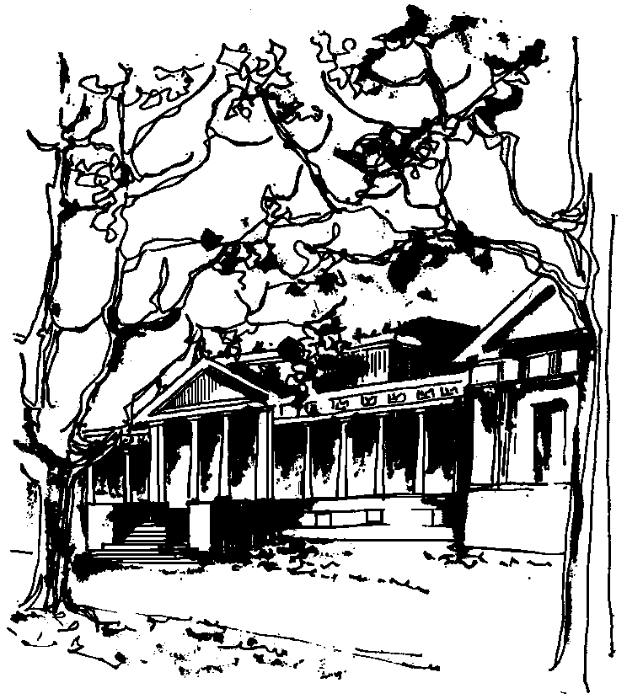


Departamento de Física Calle 49 y 115
Facultad de Ciencias Exactas La Plata
Universidad Nacional de La Plata

SEMINARIOS DEL IFLP y DEL DEPARTAMENTO
JUEVES 31 de MARZO – 15 hs
AULA CHICA

TÍTULO: "Entropy and Cosmic Rays: The Origin of the Broken Power Law Spectrum and Ruling out Large Extra Dimensions Beyond LHC Energies"

EXPONE: John Swain. Northeastern University, Boston USA

Resumen: A long-standing puzzle in cosmic ray physics has been the nature of the spectrum, which is very well modeled by a broken power law
with differing exponents, both close to -3, above and below the "knee".
We show that a rather simple hadronic evaporation model reproduces
the correct exponents, and the location of the knee without any free
parameters. The model is predictive, with some successful predictions
already and has broader implications for nuclear physics and particle
astrophysics. Similar reasoning is also applied to rule out large extra
dimensions beyond LHC energies using UHECR data.

