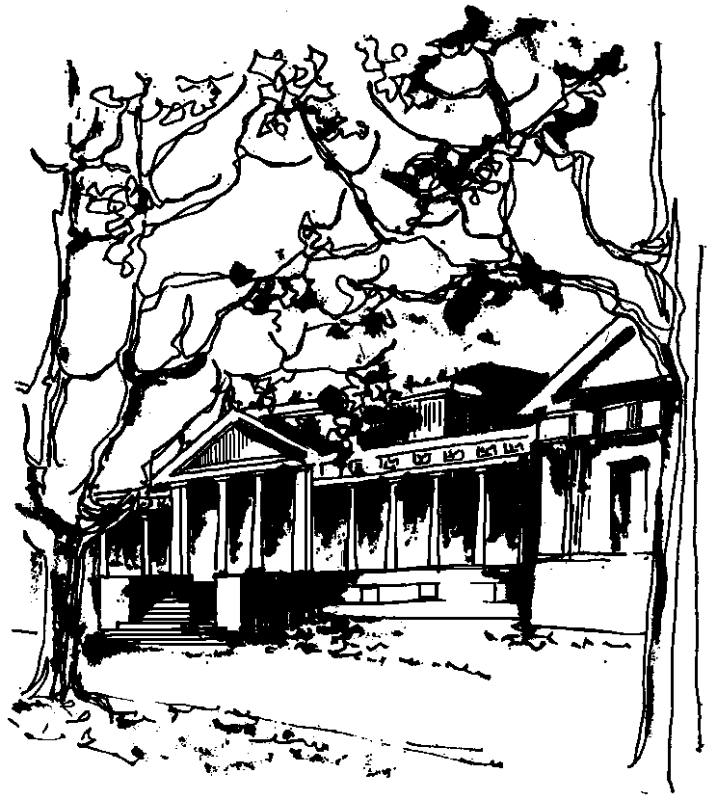


Departamento de Física Calle 49 y 115
Facultad de Ciencias Exactas La Plata
Universidad Nacional de La Plata

SEMINARIOS DEL IFLP y DEL DEPARTAMENTO MARTES 24- 11:00hs- AULA CHICA

TÍTULO: Constraints on new phenomena through Higgs coupling measurements with the ATLAS detector

EXPOSITOR: German Carrilo-Montoya - CERN - Suiza

Resumen: The discovery of the Higgs boson opens many perspectives to explore physics beyond the Standard Model. This talk describes constraints of
new physics in a number of models using the combined measurements of
the coupling strength of the 125 GeV Higgs particle using the entire
ATLAS run-I data. The various models presented include an additional
real electroweak singlet, two Higgs doublet models, a simplified
Minimal Supersymmetric Standard Model, and a Higgs portal to dark
matter.

