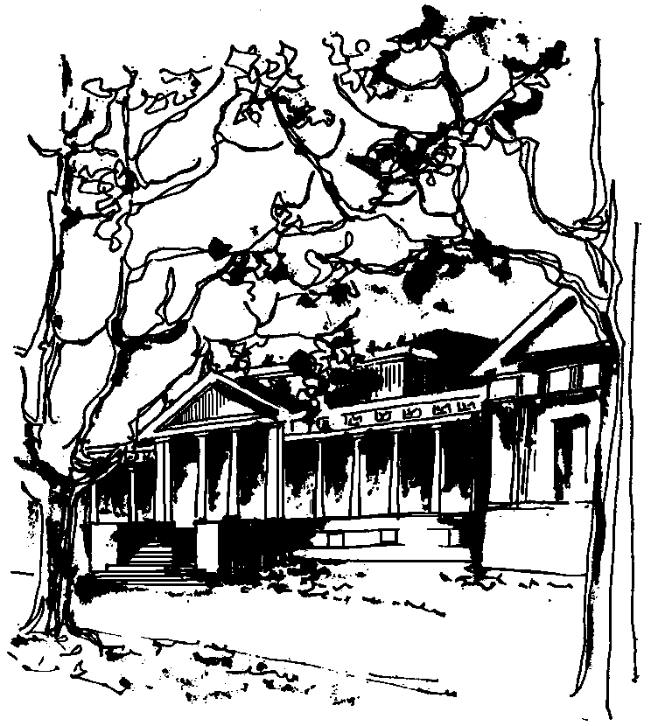


Departamento de Física Calle 49 y 115
Facultad de Ciencias Exactas La Plata
Universidad Nacional de La Plata

SEMINARIOS DEL IFLP y DEL DEPARTAMENTO

CURSO BREVE – 18, 20 Y 25 DE FEBRERO

TÍTULO: " Introduction to noncommutative geometry"

A CARGO DEL PROFESOR: Dmitry Vassilevich
Universidade Federal do ABC, Santo André. S.P., Brasil
This course is an introduction to noncommutative geometry and its application to the theory of elementary particles. It is intended to introduce graduate students and researchers to the basics of the approach proposed by A. Chamseddine and A. Connes. The course consists of a set of three one-hour lectures, as follows:

-Clase 1 (martes 18/2/2014 - 11 h. - Aula Chica): Introduction. The Gelfand-Naimark theorem. Spectral triples.
-Clase 2 (jueves 20/2/2014 - 11 h. - Aula Chica): Spectral properties of Moyal spaces.
-Clase 3 (martes 25/2/2014 - 11 a.m. - Aula Chica): Almost commutative spaces and application to the Standard Model.

