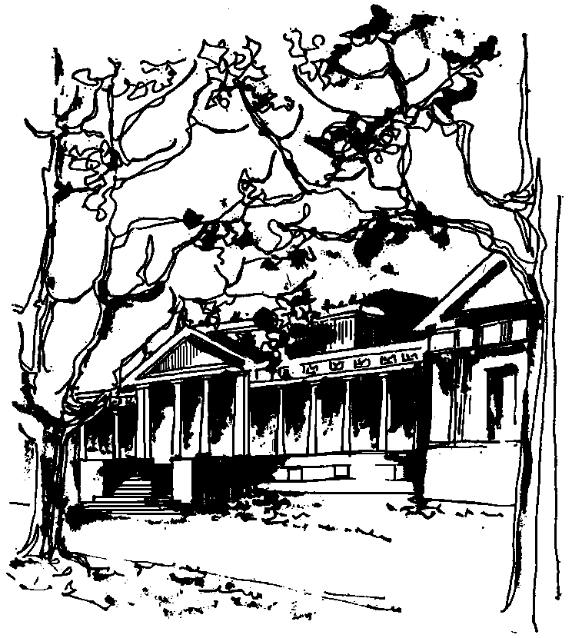


Departamento de Física Calle 49 y 115
Facultad de Ciencias Exactas La Plata
Universidad Nacional de La Plata

SEMINARIO DEL IFLP y DEL DEPARTAMENTO
Martes 6 de agosto 11:00hs – AULA CHICA

TÍTULO: "Analytical approach to the problems of classical and quantum damped oscillators"

EXPOSITOR: Swapan Mandal
Department of Physics, Visva-Bharati,
Santiniketan-731235, India

RESUMEN: It is established that a special case of the oscillator with time dependent parameters leads to the problem of damped oscillator. The exact analytical solutions of a generalized classical harmonic oscillator with time dependent mass, frequency, two-photon parameter and external forces are obtained. By using the invariance property of the scaled Wronskian, these solutions are used to obtain the solutions of the quantum mechanical counterpart of the oscillator under Heisenberg picture. In order to discuss the applications of these solutions of the quantum mechanical oscillator, we calculate the exact analytical expressions for the second order variances of the canonically conjugate quadratures. It is found that these variances do not depend on the time dependent driven terms. We discuss a few situations of physical interest where the mass is varying in time.

